# Lab: Working with ASP.NET MVC

# Your first Book Library!

If you successfully complete all steps, you will have “Book Library” application with the following functionality:

* **Register User**
* **Login User**
* **Create New Book**
* **Edit Existing Book**
* **Delete Existing Book**
* **List All Books**

## Create New Project

Creating the project is similar to the “To Do List”. This time leave the authentication to “**Individual User Authentication**”:

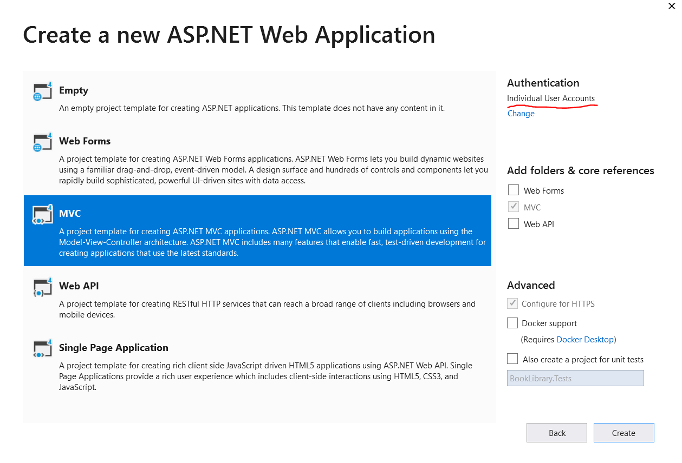

## Edit the Application Name

Go to your main layout (_Layout.cshtml) and edit the following lines:

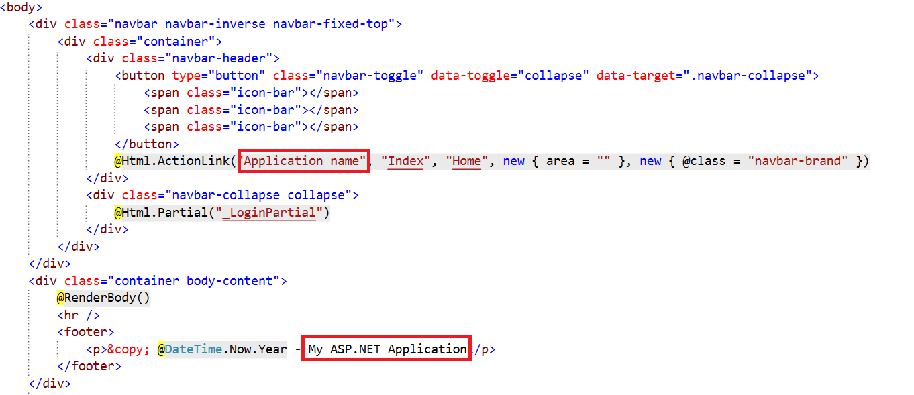

We are done with the layout for now.

## Simplify the Registration

Go to your “App_Start/IdentityConfig.cs” file. Find the following lines:

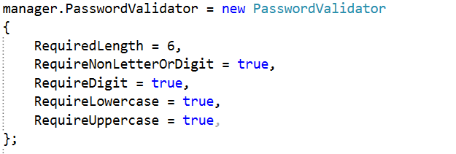

Edit them to receive this result:

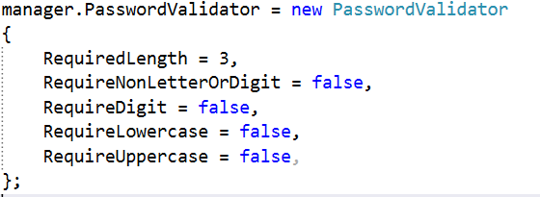

This will simplify our password. Now we need to edit the models that validate our data. Go to the “**Models**/ManageViewModels.cs”. Find this line:

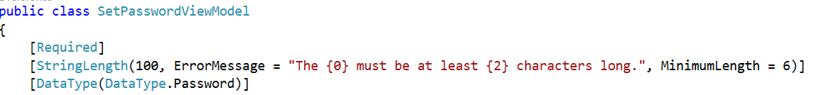

Edit the minimum length to 3 symbols. You will find similar line in the ChangePasswordViewModel class. Edit the minimum length there too:

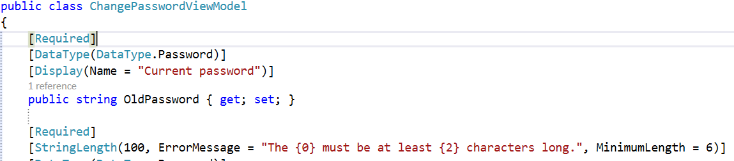

Use 3 symbols again.

Finally, we should go to the AccountViewModels.cs file. Find the lines that validate the password length, and change the value to 3 symbols. Here is how it should look like:



## Create the Book Model

Create a new class in your **Models** folder:

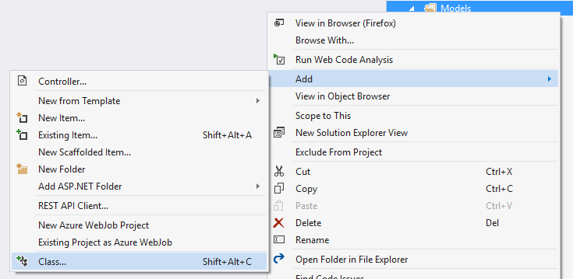

Name the class Book.cs:

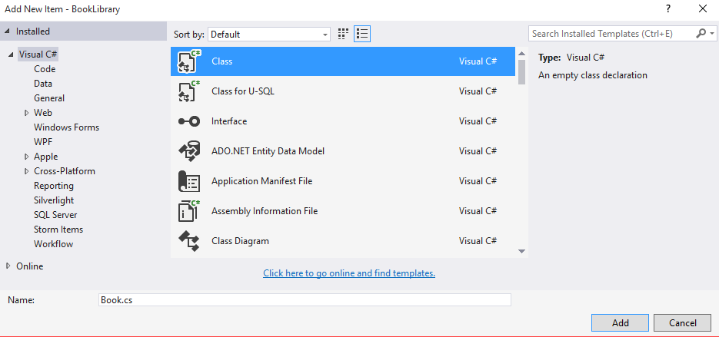

Add the following code:

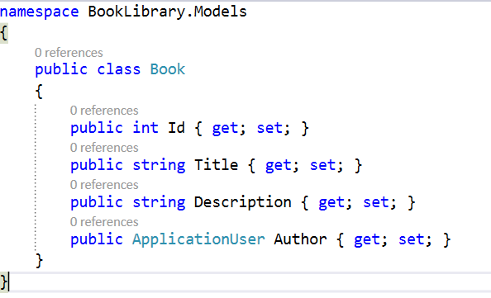

## Extract the DbContext

Create a new model and name it “ApplicationDbContext”.

Go to your IdentityModels.cs file and find the ApplicationDbContext class.

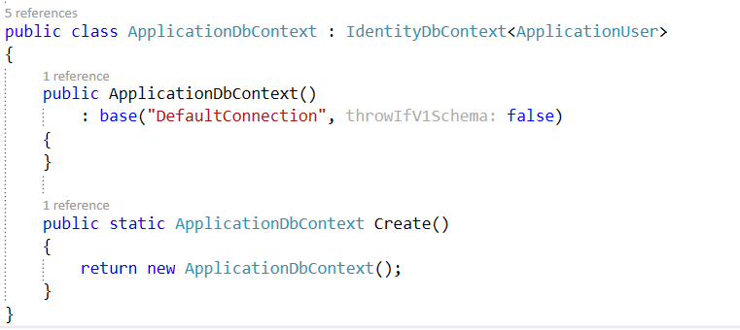

**Cut** the class and paste it to the file you’ve just created. **Replace** the **existing** **class** in the file. You should have this:

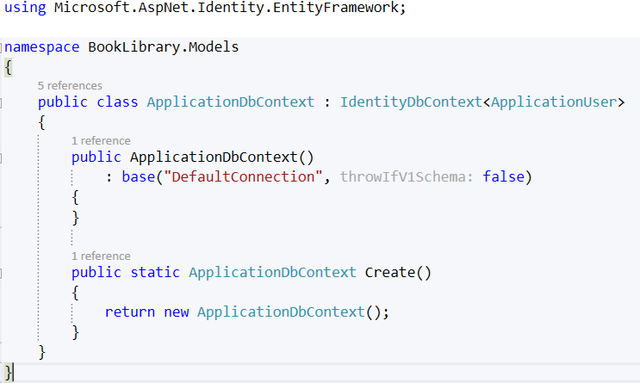

Add the following code:

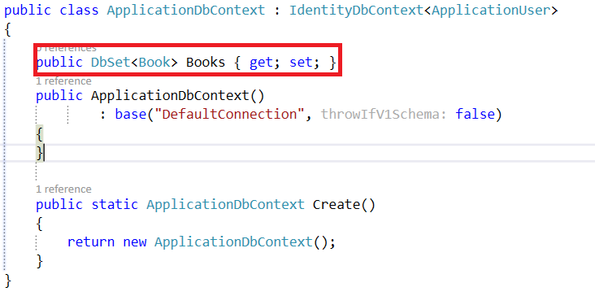

## Run the Application for the First Time

Don’t register a new user just yet! You should see this:

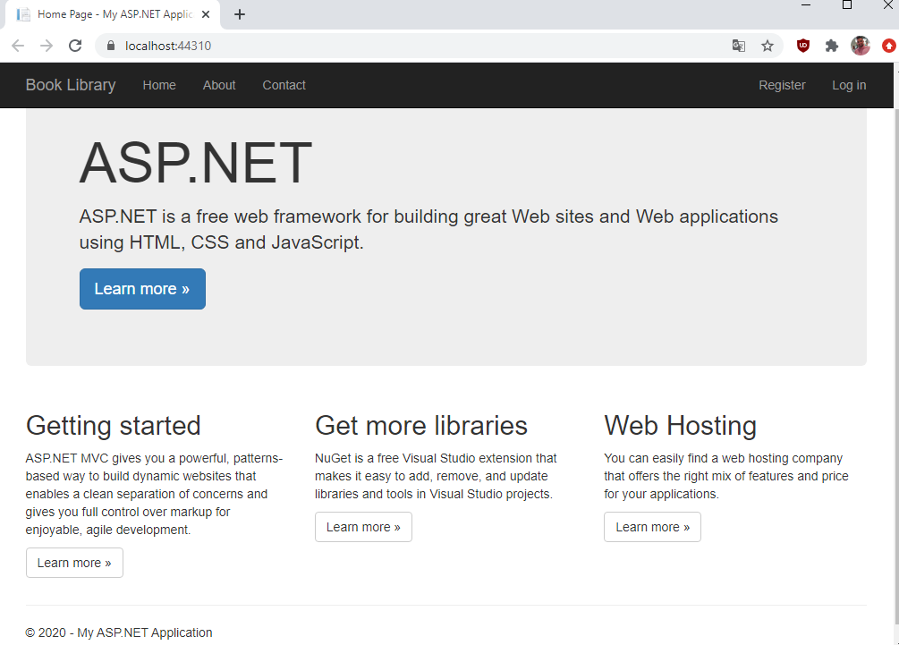

## Add Full Name to Our User

Go to your IdentityModels.cs file and write the following line:

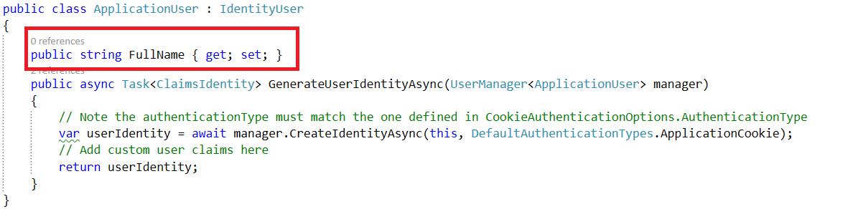

Now go to the AccountViewModels.cs and find the RegisterViewModel class. Add the following lines:

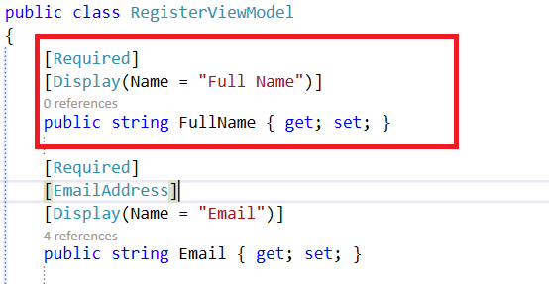

We are almost done. Go to your AccountController.cs. Find the Register **post** method:



Add this, to the existing line:

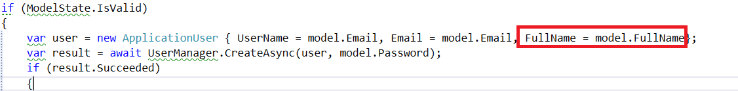

Finally go to the register view located in “Views/Account/Register.cshtml”. Write the following code:

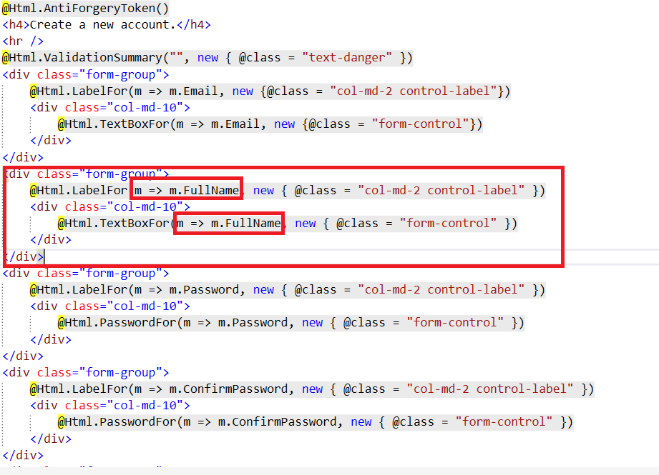

## Register New User

Run the application and try to register a new user:

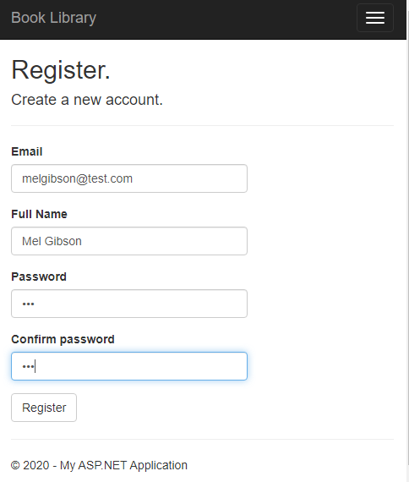

If it works you will be logged in, and you will see welcome message like this:



## Create the Book Controller

Add new scaffolded item to your **Controllers** folder:

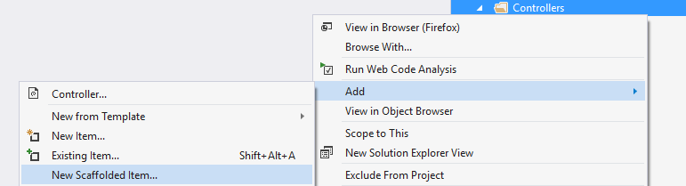

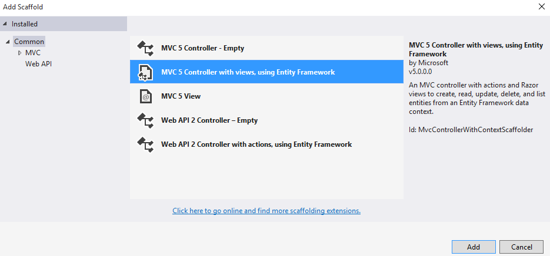

Use your **Book** **Model** and your **ApplicationDbContext** as shown in the image below:

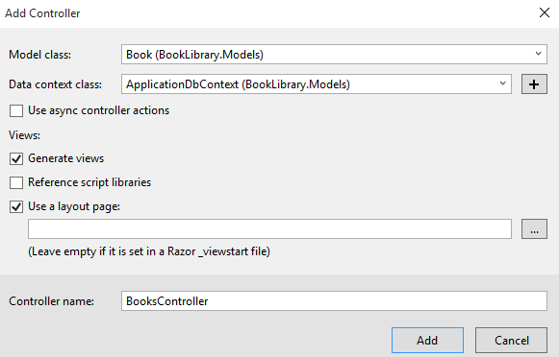

## Edit the User Layout

Go to your login layout**[ _loginPartial.cshtml** ] and add the following code:

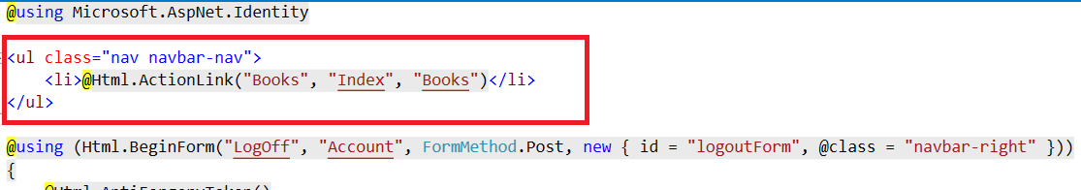

Now if you login, you will see this button (Books):



When you click on it, you will see this page:

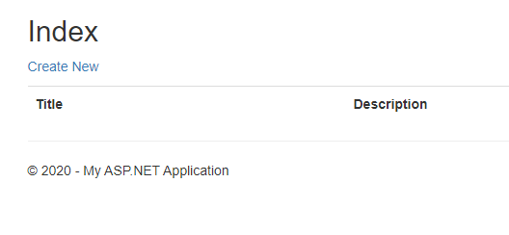

Don’t create new books yet!

## Add Author Info

Right now our **CRUD** operations don’t add the current user to our DB. We need to fix that. Find the Create method in your BooksController. It should look like this:

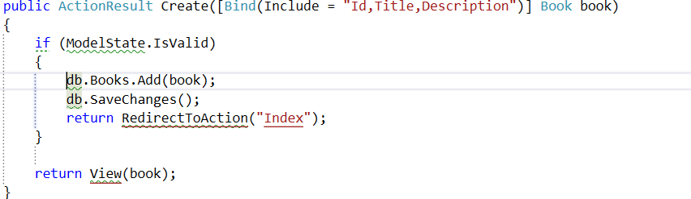

Add the following lines of code to the if statement:

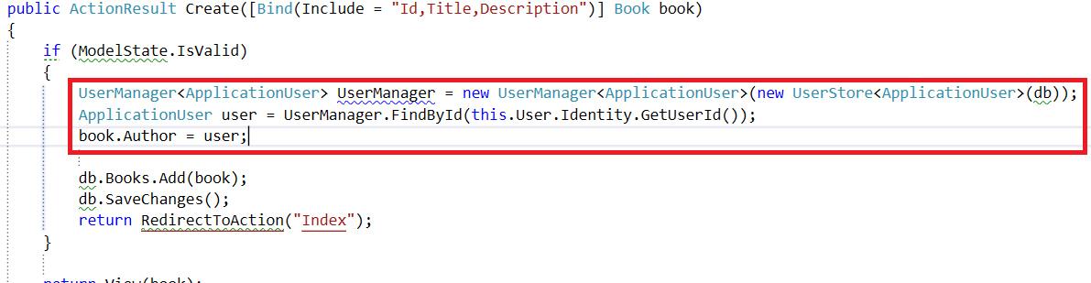

That will add the author to the book object.

## Show the Author

Our final step is to show the author of the book. We will do that by finding the Details method in our BookController. You should have something like this:

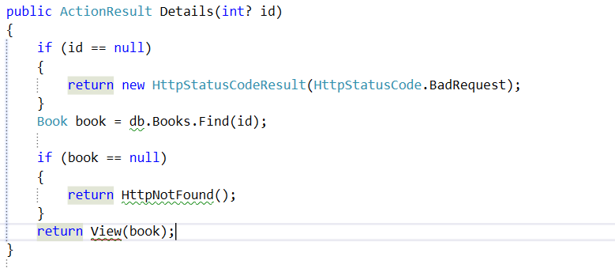

We will edit one of those lines, with LINQ query:

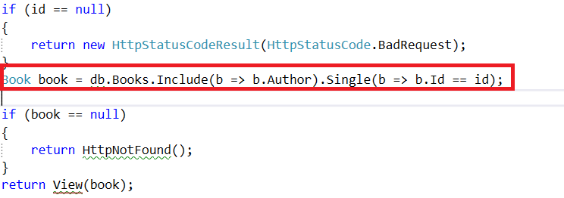

We are almost done. Let’s go to our “Views/Books/Details.cshtml” file. It should contain a div tag, that looks like this:

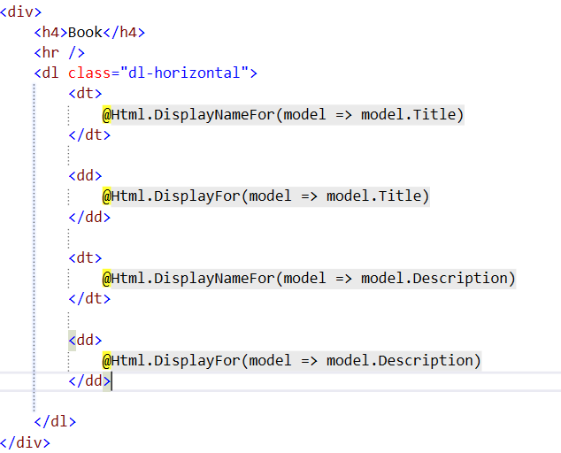

Add the following element:

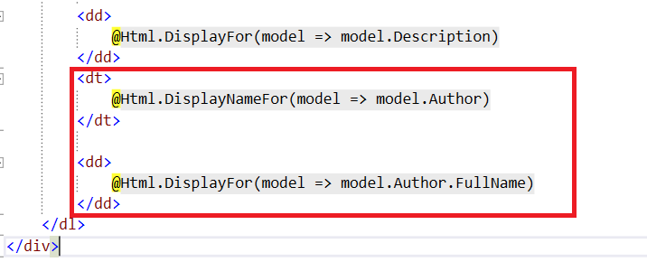

You are ready to play with your Book Library now!